Salah Activity Tracker



Supervised By: Dr. Onaiza Maqbool
Submitted By: Tayyab Mehboob

Department of Computer Science
Quaid-i-Azam University Islamabad
Session (2022 - 2026)

Certificate of Approval

This is to certify that the project “Salah Activity Tracker”, submitted by Tayyab Mehboob (Reg. No.
04072213035), has been accepted by the Department of Computer Science, Quaid-e-Azam University, Islamabad, in partial fulfilment of the requirements for the Bachelor’s in Computer Science. The work was completed under the supervisor Dr. Onaiza Maqbool and has been reviewed and recommended for acceptance by the undersigned.

Supervisor: ________________

Dr. Onaiza Maqbool
Department of Computer Science,
Quaid-e-Azam University, Islamabad

Chairperson: ________________

Dr. Ayaz Hussain
Department of Computer Science,
Quaid-e-Azam University, Islamabad

Project Coordinator: ________________

Dr. Akmal Saeed Khattak
Department of Computer Science,
Quaid-e-Azam University, Islamabad

Date: _____________

ACKNOWLEDGEMENT
I want to thank Allah Almighty who has bestowed upon me innumerable blessings, guidance, and strength such that I was able to complete this project with lot of success, SalahMate- AI-Based Salah Activity Tracker. Without his mercy and support this achievement would not have been possible.

I would like to express my sincere appreciation to my respected supervisor, Dr. Onaiza Maqbool, for her invaluable guidance, continuous encouragement and insight feedback throughout the development of this project. His mentorship played a vital role in refining the design, architecture and overall direction of SalahMate.

I am deeply grateful to my family for their unwavering support, patience and constant motivation. Their encouragement has been the foundation of my determination and perseverance during the completion of this Final Year Project. I also need to acknowledge the great support offered by our great Head of Department Dr. Ayaz Hussain that created an environment of innovation and growth in the academic realm.

To my close friends, whom I so passionately thank, Wajeeha Kamran, Abdur Rehman, Hussain Ali, and Taha Fayyaz, I acknowledge that their talks, support and company on this journey were more manageable and encouraging.

I’m immensely thankful to Mam Onaiza Maqbool for teaching us Software Construction and equipping us with essential knowledge of software design principles, architecture and development methodologies, which proved fundamental during the implementation of this project. I also want to say a big thank you to my respected teachers; Sir Rabi, Sir Mudassir, Sir Akmal Khattak, Sir
Muazzam Khattak, Mam Memoona, Mam Ifrah, Sir Ali Naqi and Sir Ghazanfar, who have given in to teaching programming concepts and software engineering practices which formed the basis of achieving this milestone.

Finally, I would like to thank Habib Farooq for his assistance in refining the application content and contribution valuable suggestions for improving the front-end user interface of SalahMate.

I acknowledge and appreciate everyone who contributed directly to the successful completion of this project. Your aid and encouragement have been very indispensable.

ABSTRACT
It is difficult for Muslims to claim that they offer their prayers at the same time every day in the modern world. This is a result of our hectic lifestyles and lack of tools for tracking our prayers. There are many apps that tell us what time to pray but they do not do much else to help us. They do not tell us to keep track of our progress or encourage us to keep praying. They do not give us advice that’s just for us. Muslims need a system that will help them with their Salah and encourage them to keep praying in a supportive way. This system should help Muslims with their prayers and help them to be consistent with them in a respectful and positive way. The system should be smart and helpful. It should only help Muslims with their Salah and encourage spiritual consistency.
Many of the available apps do not provide options like prayer history, streak, weakness lessons, tailored motivational messages, built-in Quran reader with translation and Hijri calendar options. This is because users find it difficult to evaluate their consistency in prayers with time and which pray they are consistently failing to do. Moreover, existing solutions cannot yet include AI-guided motivation that is flexible based on an age group of the user without causing guilt messages.
The proposed system is an SalahMate-an AI-Based Salah Activity Tracker, designed to help user monitor, analyze and improve their prayer habits. The application enables them to track their prayers as prayed or missed, keep detailed records and track streaks and provide statistical reports on daily and weekly completion rate. SalahMate offers prayer times according to the location, Hijri calendar and date view, Surah by Surah, Chapter by Chapter, Quran Urdu and English translation and marker of Asma-ul-Husna with semantics.
One point that deserves notice is the motivational module, which can be considered the important part of SalahMate; it tracks the completion pattern of the user and over time, helps identify the regularly skipped prayers, and delivers the customized and respectful and encouraging messages, which are related to the age segmentation chosen. The system is designed to help people feel good about themselves and avoid feeling guilty. It will be done by promoting steady improvement in their spiritual life.
The SalahMate application sends reminders to pray. This helps people stay on course, which is beneficial. They get reminders at the right time, depending on where they are. More features that help users understand their own behavior could be added to the program in the future. This can be done by using intelligence and making sure the system works on all devices. The system can also be used to bring people and help them support each other in their spiritual journey. The main goal of SalahMate is to create a complete and easy to use application that helps people be consistently aware of themselves and grow spiritually. SalahMate is about helping people with their spiritual discipline and growth and it does this by providing a system that is tailored to their needs and helps them stay on track with their spiritual life, which is what SalahMate is all about.

Table of Contents
Chapter 1 Software Project Management Plan........................................................ 9
1.1 Introduction: ................................................................................................................................. 10
1.2 Problem Statement: ...................................................................................................................... 10
1.4 Major Functionalities: ................................................................................................................... 10
1.5 Objective: ...................................................................................................................................... 11
1.6 Tools and Techniques: ................................................................................................................... 11
1.7 Users: ............................................................................................................................................ 11
1.8 Software Process Model: .............................................................................................................. 11
1.9 Project Management Plan: ........................................................................................................... 11
1.13 Gantt Chart ................................................................................................................................. 17
2.0 Software Requirement Specification: ............................................................... 19
2.1 Introduction: ................................................................................................................................. 19
2.2 Functional Requirements: ............................................................................................................ 19
2.2.1 Authentication ........................................................................................................................... 19
2.2.2 Prayer Tracking ........................................................................................................................... 19
2.2.3 Prayer Timing ............................................................................................................................. 20
2.2.4 Analytics & Progress Visualization ............................................................................................. 20
2.2.5 Personalized Motivation ............................................................................................................ 20
2.2.6 Notification ................................................................................................................................ 21
2.2.7 Profile Management .................................................................................................................. 21
2.2.8 Hijri Calendar ............................................................................................................................. 21
2.2.9 Asma-ul-Husna ........................................................................................................................... 21
2.2.10 Quran Pak ................................................................................................................................ 21
2.3 Non-Functional Requirements: ..................................................................................................... 22
2.3.1 Performance .............................................................................................................................. 22
2.3.2 Security ...................................................................................................................................... 22
2.3.3 Usability...................................................................................................................................... 22
2.3.4 Reliability ................................................................................................................................... 22
2.4 User Characteristics: ..................................................................................................................... 22
2.5 Constraints: ................................................................................................................................... 23
2.6 Major Input and Output: .............................................................................................................. 23
2.6.1 Major Inputs: ............................................................................................................................. 23
2.6.2 Major Outputs: .......................................................................................................................... 23
2.7 Use Cases Diagram: ....................................................................................................................... 24
2.8 Use Case Description: ................................................................................................................... 25
2.8.1 Login/Signup .............................................................................................................................. 25
2.8.2 Set/Update Location................................................................................................................... 25
2.8.3 Mark/Unmark Prayers ................................................................................................................ 26
2.8.4 View Prayer Logs ........................................................................................................................ 26
2.8.5 View Prayer Stats ....................................................................................................................... 27
2.8.6 Receive Motivational Messages ................................................................................................. 27
2.8.7 Manage Notifications ..................................................................................................................28
2.8.8 Select Notification Tone ............................................................................................................. 28
2.8.9 Manage Profile ........................................................................................................................... 29
2.8.10 Change Theme ......................................................................................................................... 29
2.8.11 View Hijri Calendar .................................................................................................................. 30
2.8.12 Read Quran Pak ....................................................................................................................... 30
2.8.13 View Asma-ul-Husna ................................................................................................................ 31
2.9 System Sequence Diagram: ........................................................................................................... 32
2.9.1 Login/Signup .............................................................................................................................. 32
2.9.2 Set/Update Location................................................................................................................... 32
2.9.3 Mark/Unmark Prayers ................................................................................................................ 33
2.9.4 View Prayer Logs ........................................................................................................................ 33
2.9.5 View Prayer Stats ....................................................................................................................... 34
2.9.6 Receive Motivational Messages ................................................................................................. 34
2.9.7 Manage Notifications ................................................................................................................. 35
2.9.8 Select Notification Tone ............................................................................................................. 35
2.9.9 Manage Profile ........................................................................................................................... 36
2.9.10 Change Theme ......................................................................................................................... 36
2.9.11 View Hijri Calendar .................................................................................................................. 37
2.9.12 Read Quran Pak ....................................................................................................................... 37
2.10 Domain Model: ........................................................................................................................... 39
2.11 Class Diagram: ............................................................................................................................. 40
2.12 Entity Relationship Diagram: ....................................................................................................... 40
3.0 System Design: ................................................................................................ 42
3.1 Architecture Diagram: ................................................................................................................... 43
3.2 Sequence Diagram: ....................................................................................................................... 43
3.2.1 Login/Signup .............................................................................................................................. 44
3.2.2 Set/Update Location................................................................................................................... 44
3.2.3 Mark/Unmark Prayers ................................................................................................................ 45
3.2.4 View Prayer Logs ........................................................................................................................ 45
3.2.5 View Prayer Stats ....................................................................................................................... 46
3.2.6 Receive Motivational Messages ................................................................................................. 46
3.2.7 Manage Notifications ................................................................................................................. 47
2.2.8 Select Notification Tone ............................................................................................................. 47
3.2.9 Manage Profile ........................................................................................................................... 48
3.2.10 Change Theme ......................................................................................................................... 48
3.2.11 View Hijri Calendar .................................................................................................................. 49
3.2.12 Read Quran Pak ....................................................................................................................... 49
3.2.13 Read Quran Pak ....................................................................................................................... 50
3.3 Interface Design: ........................................................................................................................... 51
3.3.1 Login/signup .............................................................................................................................. 51
3.3.2 Home Screen .............................................................................................................................. 52
3.3.3 Statistics Screen ......................................................................................................................... 52
3.3.4 Hijri Calendar ............................................................................................................................. 53
3.3.5 Quran Pak Screen ....................................................................................................................... 53
3.3.6 Prayer logs Screen ...................................................................................................................... 54
3.3.7 Setting Screen ............................................................................................................................ 54
4.0 Software Testing: ............................................................................................. 55
4.1 Introduction: ................................................................................................................................. 56
4.2 Test plan: ....................................................................................................................................... 56
4.3 Features for Testing: ...................................................................................................................... 56
4.4 Test Cases: ..................................................................................................................................... 56
4.4.1 User Login and Signup ............................................................................................................... 56
4.4.2 Prayer Tracking (Mark Prayed/not Prayed) ................................................................................ 57 4.4.3 Prayer Logs and History ............................................................................................................. 57
4.4.4 Streak Calculation ...................................................................................................................... 57
4.4.5 Location-based prayer timings ................................................................................................... 57
4.4.6 Hijri Calendar ............................................................................................................................. 58
4.4.7 Quran Pak (Surah and Chapter with Translation) ....................................................................... 58
4.4.8 Asma-ul-Husna ........................................................................................................................... 58
4.4.9 AI-based Motivational Messages ............................................................................................... 58
4.4.10 Prayer Remainder Notification ................................................................................................. 59

CHAPTER NUMBER 1

SOFTWARE PROJECT MANAGEMENT PLAN

Chapter 1 Software Project Management Plan
This chapter presents the planning and management aspects of the proposed project. It outlines the project background, scope, objectives and overall development directions.
1.1 Introduction:
This first chapter introduces the description of Salah Activity Tracker, what the problem statement is, and how it will be designed and developed to solve that problem. This chapter will also explain the scope, requirements and objectives of the project.

1.2 Problem Statement:
Many people don’t have enough time to make their Salah routine consistent. This is because there are many things due to which their lives get distracted very easily and they do not have any good way or any tool to track their progress. Current prayer apps just show schedules and reminders but lack behavioral tracking, personal motivation and analytics. It was not that simple to increase the consistency as users did not recognize the most common Salah they did not perform. There is also no unified system that offers age-appropriate guidance, streak monitoring history logs and customizable reminders. Thus, there is a need to be a more intelligent and big data oriented solution that can assist users to exercise discipline, remain motivated and reinforce their routine Salah routine.

1.3 Project Description:
Salah Activity is an app (Mobile Application) designed to help people to offer their prayers on time. Thus, there is a need to be a more intelligent and big data-oriented solution that can assist users to exercise discipline, remain motivated and reinforce their routine Salah routine. The system provides age-based personalized motivation, AI-generated encouragement, and detailed analytics to help users to understand their habits and improve discipline. The user can set up reminders with personalized tones and set or update their location to receive precise prayer timings. Additionally, the app helps people of all ages establish a consistent and significant spiritual routine by storing records, displaying streaks, and providing an intuitive user interface.
1.4 Major Functionalities:
- Track daily Salah completion.
- Display location-based prayer timings.
- Provide basic and advanced prayer statistics
- AI-based personalized motivational message
- Notification and reminder management
- Profile and age-group based personalization

1.5 Objective:
- To help users maintain consistency in daily Salah
- To provide structured tracking and analytics of self-improvement
- To motivate user through personalized and respectful guidance
- To identify prayer patterns and areas of improvement
- To promote long-term discipline and spiritual growth

1.6 Tools and Techniques:
It is a mobile-based application, and the following tools have been used in development:
- Frontend Framework: React Native for developing cross-platform mobile applications.
- Backend: Nest.js

3. Database: PostgreSQL and Prisma
4. AI Integration: API-based model for personalized motivational message generation.
5. MS Word for Documentation

1.7 Users:
This application is designed for teenagers, adults and senior users who wish to track and improve their daily Salah routine. Users will sign up or login to the mobile application to record prayer completion, view progress statistics, receive remainders and get personalized motivational guidance. There is no separate admin role, all interactions are performed directly by the user through the application interface.
1.8 Software Process Model:
Agile Model will be used for development because:
- It supports continuous refinement of requirement based on supervisor feedback and system evaluation.
- It allows incremental development, making it easier to implement, test, and improve features throughout the project lifecycle.
  - Project Management Plan:
This section will elaborate on how the task will be divided among different people and resources. What will be the deliverables, risks and constraints?
  - Requirements Analysis Phase:
1.10.1 Requirements Identification:
Task Description | Deliverables | Resources  Needed | Dependencies &  Constraints | Risks
The initial step of this project is the  identification of requirements which are functional and nonfunctional. | Requirements are collected  and reviewed | People:  Tayyab Mehboob  Dr Onaiza Maqbool  Software:  MS Word  Hardware: Laptop | None | Incomplete or misunderstood requirements.
Table 1.1 Requirement Identification Task 1.10.2 Define Use Cases:
Task Description | Deliverables | Resources Needed | Dependencies &  Constraints | Risks
After clearing all requirements software architecture will start from Use case diagrams | Use Cases are written and then should be submitted as a Use-Case Diagram in  Word format | People:  Tayyab Mehboob  Dr Onaiza Maqbool  Software:  MS Word, Visual  Paradigm  Hardware: Laptop | Requirements must be clear. | Unclear requirements
Table 1.2 Defining Use cases Task

1.10.3 Develop Domain Model:
Task Description | Deliverables | Resources Needed | Dependencies &  Constraints | Risks
After we know about the use cases of a project, we will start designing Domain Model for the system | Domain  model will be reviewed | People:  Tayyab Mehboob  Dr Onaiza Maqbool  Software:  MS Word, Draw.io  Hardware: Laptop | Use cases must be defined before we move toward Domain  Model | ill-defined use cases
Table 1.3 Domain model development Task 1.10.4 ERD Designing:
Task Description | Deliverables | Resources Needed | Dependencies &  Constraints | Risks
In this step, we make ERD Designs for the database | ERD Design  will be reviewed | People:  Tayyab Mehboob  Dr Onaiza Maqbool  Software:  MS Word, Visual  Paradigm  Hardware: Laptop | We must know the design of the domain model so we can see dataflow and what data we will need in this step | Any error in  a  Domain model
Table 1.4 ERD designing Task
1.10.5 SRS Completion:
Task Description | Deliverables | Resources Needed | Dependencies &  Constraints | Risks
This task includes making software requirements specification document | SRS document  (Word/ PDF) | People:  Tayyab Mehboob Dr Onaiza Maqbool Software: MS Word Hardware: Laptop | None | None

Table 1.5 SRS Completion Task
1.11 Designing Phase:
1.11.1 Develop Design:
Task Description | Deliverables | Resources Needed | Dependencies &  Constraints | Risks
Development of highlevel architectural design | Architectural  Diagram (PDF/  Word) | People:  Tayyab Mehboob  Dr Onaiza Maqbool  Software:  MS Word  Hardware: Laptop | Requirement analysis must be completed | Ill-defined requirements.
Table 1.6 Design Development Task 1.11.2 Develop Interfaces:
Task Description | Deliverables | Resources Needed | Dependencies &  Constraints | Risks
This task includes the design of user interfaces including login, dashboard, prayer tracking, analytics and settings screens. | UI Designs (Figma/PDF) | People:  Tayyab Mehboob  Dr Onaiza Maqbool  Software: MS Word, Figma Hardware: Laptop | Architectural design must be completed | Ill-defined requirements, Use cases

Table 1.7 Interface Development Task
1.11.3 Class Diagram Designing:
Task Description | Deliverables | Resources Needed | Dependencies &  Constraints | Risks
In this step, we create a Class Diagram to show the flow of data and how they relate to each other. | Class Diagram  (PDF/ Word) | People:  Tayyab Mehboob  Dr Onaiza Maqbool  Software:  MS Word, Draw.io  Hardware: Laptop | Architectural Design must be completed | ill-defined architectural design, and domain model.
Table 1.8 Class Diagram Task
1.11.4 Sequence Diagram Designing:
Task Description | Deliverables | Resources Needed | Dependencies &  Constraints | Risks
In this step, we make a Sequence Diagram to show the flow of data | Sequence  Diagram (PDF/  Word) | People:  Tayyab Mehboob  Dr Onaiza Maqbool  Software:  MS Word, Draw.io  Hardware: Laptop | Architectural Design must be completed | Incorrect flow modeling
Table 1.9 Sequence Diagram Task 1.11.5 Design Phase Verification:
Task Description | Deliverables | Resources Needed | Dependencies &  Constraints | Risks
Verification and review of all design artifacts before implementation. | Design phase is completed it’s document will be reviewed. | People:  Tayyab Mehboob  Dr Onaiza Maqbool  Software:  MS Word  Hardware: Laptop | The whole Design phase must be completed | None
Table 1.10 Design Phase Verification Task
1.11.6 Software Test Documentation:
Task Description | Deliverables | Resources Needed | Dependencies &  Constraints | Risks
In this step, we define the test cases | Test cases  document | People:  Tayyab Mehboob  Dr Onaiza Maqbool  Software:  MS Word  Hardware: Laptop | Design phase should be complete | None
Table 1.11 Software Test Documentation Task
1.12 Implementation Phase:
1.12.1 System Implementation:
Task Description | Deliverables | Resources Needed | Dependencies &  Constraints | Risks
In this step, we develop the Mobile application | Complete application source code (ZIP format) | People:  Tayyab Mehboob  Dr Onaiza Maqbool  Software:  VS Code, React Native,  Node.js, Express.js,  MongoDB  Hardware: Laptop | The whole Design phase must be completed | None
Table 1.12 System Implementation

1.13 Gantt Chart

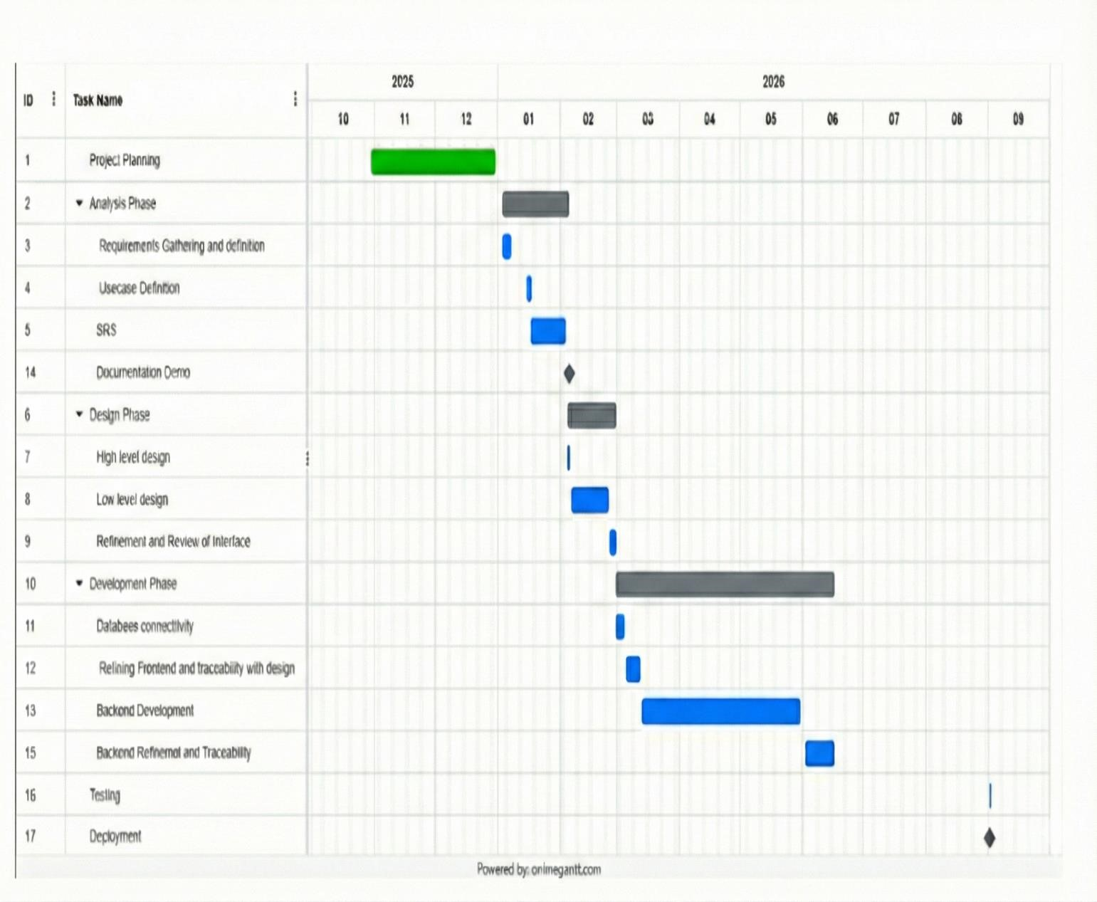

Figure 1 Gannt Chart

CHAPTER NUMBER 2

SOFTWARE REQUIREMENTS SPECIFICATIONS

2.0 Software Requirement Specification:
The Software Requirement Specification (SRS) defines the functional and non-functional requirements of the proposed system. It offers a thorough explanation of how the system will function and communicate with users. This chapter outlines the overall characteristics of the application, including user requirements, system functionalities, constraints and system models. It also presents the use cases, system sequence diagrams, domain model and database design that describe the structure and behavior of the system.

2.1 Introduction:
This chapter first describes the attributes of the software system. It highlights the user characteristics and major constraints of the tool. It also elaborates on the use cases and system sequence diagrams. Finally, this chapter explains the domain model and database design of the project.
2.2 Functional Requirements:
Functional requirements for this system are below:
2.2.1 Authentication:
- System should allow users to sign up or login.
- System should store user details.
- The system should maintain user sessions.
2.2.2 Prayer Tracking:
- Users should mark each salah as prayed or not.
- System should store prayer logs each day.
- System should calculate daily completion percentage.
- System should maintain current streak, representing the number of consecutive days in which the user has successfully offered all five daily prayers.
- The system should maintain a longest streak, representing the highest number of consecutive fully completed prayer days achieved by the user.
- The system should automatically update and recalculate prayer logs, completion percentage, and streak values whenever the user marks or unmarks a prayer.
- The system should reset or adjust the current streak if one or more obligatory prayers are missed on a day.
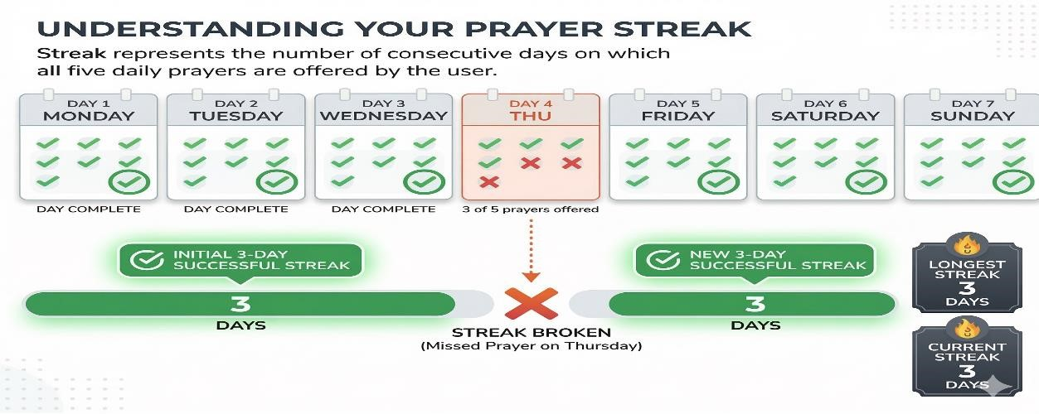
2.2.3 Prayer Timing:
- System should show location-based prayer times.
- System should allow users to manually select city.
- The system shall update prayer timings daily based on location.
2.2.4 Analytics & Progress Visualization:
- System should show weekly progress graph.
- System should display streak statistics.
2.2.5 Personalized Motivation:
- System should analyze the user`s prayer completion patterns over time.
- System should detect which specific prayer is missing most frequently.
- System should generate motivational messages based on the identified weak prayer.
- System should generate messages according to the user’s selected age group.

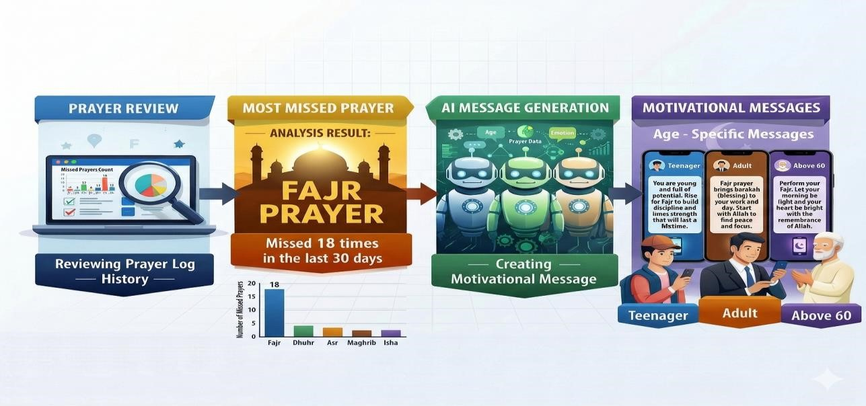

2.2.6 Notification:
- System should send remainders for each prayer.
- User should be able to choose preferred tone.
- System should allow user for enabling or disabling notifications.
2.2.7 Profile Management:
- System should allow user for the changing of name, email or age group.
- System should show the logs.
- System should show profile statistics including streak and progress.
2.2.8 Hijri Calendar:
- System should display the current Hijri date on the home screen.
- System should allow users to view the complete Hijri Calendar.
- System should highlight important Islamic dates and months.
2.2.9 Asma-ul-Husna:
- System Should display 99 names of Allah (Asma-ul-Husna).
- System should show Arabic names with English transliteration.
- System should provide meanings in both English and Urdu.
- System should allow users to scroll and view names easily.
2.2.10 Quran Pak:
- System Should allow users to read the Quran Pak digitally.
- System should provide access by Surah (1-114).
- System should provide access by chapters (1-30).
- System should display Arabic text with Urdu and English Translations.
- The system should allow smooth navigation between chapters and verses.

2.3 Non-Functional Requirements:
Non-functional requirements for this system are below

2.3.1 Performance
- The application should load screen quickly.
- Smooth scrolling of Quran and Asma-ul-Husna content.
- The application shall consume minimal battery.

2.3.2 Security
- The system shall allow access only to authenticated users.
- The system shall ensure confidentiality and integrity of user data.

2.3.3 Usability
- The application should be easy to use for all age groups.
- The UI should be clean, minimal and intuitive.
- Islamic content should be clearly readable and well-formatted.

2.3.4 Reliability
- System should not lose prayers logs during offline usage.
- System should maintain operational stability during network interruptions through graceful error handling and automated recovery.
- The system should ensure continuous access to essential Islamic content by caching retrieved data for offline usage.

2.4 User Characteristics:
Users should have knowledge about:
- Basic knowledge of using mobile applications.
- Internet literacy
- Familiarity with basic smartphone navigation.
- Interest in religious self-improvement.
- The application is designed for a board range of users categorized into different age groups:
      - Teenagers (15-19 years) who are developing the habit of offering regular prayers.
      - Adults (20-59 years) include students and working professionals who want to track and improve their prayer consistency. o Older users (60 years and above) who wish to maintain their religious practices with the help of simple digital tools.

2.5 Constraints:
- Limited mobile screen
- Internet dependency
- Notification permission required
- Accuracy of third-party APIs (Prayer time, Hijri date).
- Static religious content must be authentic and verified.

2.6 Major Input and Output:

2.6.1 Major Inputs:
Some of the major Inputs of the system are:
- Login and Sign-up credentials (email, password).
- Daily Salah status inputs (prayed/ not prayed for each prayer).
- Location input (auto-detected or manually selected city).
- Notification and alarm preferences (tones, remainder settings).
- User navigation and interaction inputs.
- Profile information updates.
- Quran navigation inputs (Surah/ Chapter selection).
- Language preference (Urdu/ English)..
2.6.2 Major Outputs:
Some of the major outputs of a system are:
- City-based prayer timings displayed to the user.
- Current Hijri date and calendar view.
- Daily and weekly analytics (graphs, streak counts, completion percentages).
- AI-generated motivational messages.
- Reminder and alarm notifications.
- Asma-ul-Husna list with Urdu and English meanings
- Quran Pak content with translation
- Profile summary (name, age group, streak, statistics).
- Prayer history logs and past performance overview.
  - Use Cases Diagram:
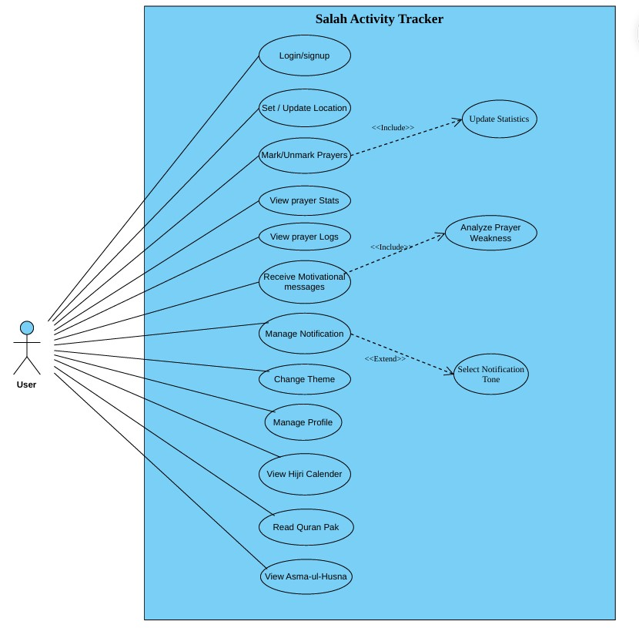
Figure 2.1 Use Case Diagram
  - Use Case Description:

2.8.1 Login/ Sign Up
ID | UC1
Name | Login/ Sign Up
Primary Actor | User
Pre-Condition | The user has not been authenticated in the system.
Post Condition | The user is successfully authenticated and redirected to the home screen.
Main Success Scenario | - The user opens the app.  - The user Login/ Sign Up.  - The user enters email and password.  - The system validates credentials.  - The user logged in successfully.
Alternative Flows or Extensions | 4.a Wrong credentials: system shows error message.  2.a New user: System creates a new account.
Frequency | Once per session
Table 2.1 Use case description of login/signup

2.8.2 Set/ Update Location
ID | UC2
Name | Set/ Update Location
Primary Actor | User
Pre-Condition | The user must allow location access or select location manually.
Post Condition | Prayer timings are updated based on selected location.
Main Success Scenario | - The user navigates to location settings.  - User selects location from list.  - System fetches new prayer timings.  - Updated timings appear on the home screen.
Alternative Flows or Extensions | 1.a Location not detected: User manually selects location.
Frequency | Occasionally
Table 2.2 Use case description of set/update location

2.8.3 Mark/ Unmark Prayers
ID | UC3
Name | Mark/ Unmark Prayers
Primary Actor | User
Pre-Condition | The user must be logged in.
Post Condition | Prayer log for that day is updated.
Main Success Scenario | - The user clicks on a prayer (e.g. Fajr).  - Select “Mark as Prayed”.  - System updates daily log.  - Statistics and streak update automatically.
Alternative Flows or Extensions | 2.a User unmark prayer: system decreases the completion percentage.  4.a User marks all prayers: system triggers streak update.
Frequency | Five times daily.
Table 2.3 Use case description of mark/unmark prayers 2.8.4 View Prayer Logs
ID | UC4
Name | View Prayer Logs
Primary Actor | User
Pre-Condition | Logs must exist.
Post Condition | The user sees historical record.
Main Success Scenario | - User opens “Logs” screen.  - System retrieves and displays previous day’s prayer status.
Alternative Flows or Extensions | 1.a No logs available: show empty state message.
Frequency | Daily, weekly or monthly
Table 2.4 Use case description of view prayer logs

2.8.5 View Prayer Stats
ID | UC5
Name | View Prayer Stats
Primary Actor | User
Pre-Condition | System must have enough historical data.
Post Condition | The user is presented with analytics and charts.
Main Success Scenario | - User opens Stats section.  - System loads weekly/ monthly graphs.  - Streak count and progress summary display.
Alternative Flows or Extensions | 2.a Insufficient data: show “Not enough data” message.
Frequency | Medium
Table 2.5 Use case description of view prayer stats

2.8.6 Receive Motivational Messages
ID | UC6
Name | Receive motivational messages
Primary Actor | User
Pre-Condition | System should have sufficient prayer history.
Post Condition | The user receives a personalized motivational message.
Main Success Scenario | - The user opens Motivational section.  - System analyzes prayer logs to find mostmissed Salah.
- AI generates a message based on age group + weakness.
- The user sees the motivational message.
Alternative Flows or Extensions | 2.a No history available: AI shows generic motivation.  3.a AI error: system shows fallback static message.
Frequency | Low to Medium.
Table 2.6 Use case description of receive motivational messages

2.8.7 Manage Notifications
ID | UC7
Name | Manage Notification
Primary Actor | User
Pre-Condition | Notification permission must be granted.
Post Condition | Updated remainder settings are saved.
Main Success Scenario | - The user opens Notification Settings.  - The user enables/ disables reminders.  - System saves user preferences.
Alternative Flows or Extensions | 2.a Permission disable: app ask user to enable notifications.  3.a System sends reminders accordingly.
Frequency | Low
Table 2.7 Use case description of manage notifications

2.8.8 Select Notification Tone
ID | UC8
Name | Select Notification Tone
Primary Actor | User
Pre-Condition | Notification system enabled.
Post Condition | Custom tone is set for reminders.
Main Success Scenario | - User opens Tone settings.  - User selects a sound from list.  - System saves selected tone.
Alternative Flows or Extensions | 2.a File unsupported: app shows error.
Frequency | Low
Table 2.8 Use case description of select notification tone

2.8.9 Manage Profile
ID | UC9
Name | Manage Profile
Primary Actor | User
Pre-Condition | User must be logged in.
Post Condition | Profile details are updated.
Main Success Scenario | - User opens Profile settings.  - User edit name, age group, or city.  - System updates profile.
Alternative Flows or Extensions | 2.a Invalid input: system prompts user.  3.a Network failure: changes saved later.
Frequency | Low
Table 2.9 Use case description of manage profile

2.8.10 Change Theme
ID | UC10
Name | Change Theme
Primary Actor | User
Pre-Condition | The user must be inside the app.
Post Condition | App appearance updates immediately.
Main Success Scenario | - The user opens Theme settings.  - Choosing Light or Dark.  - System applies theme.
Alternative Flows or Extensions | 2.a Auto theme mode (based on device setting).
Frequency | Medium
Table 2.10 Use case description of change theme

2.8.11 View Hijri Calendar
ID | UC11
Name | View Hijri Calendar
Primary Actor | User
Pre-Condition | The user must be Logged into the application.
Post Condition | Selected Quranic content is displayed to the user.
Main Success Scenario | - The user opens the application.  - The user navigates to the Hijri Calendar section.  - The system retrieves the current Hijri month and year.  - The user displays the full Hijri Calendar to the user.
Alternative Flows or Extensions | 3.a If internet connection is unavailable, the system shows the last cached Hijri calendar or shows the error message.  4.a If the Hijri API fails, the system notifies the user.
Frequency | Occasional
Table 2.11 Use case description of view Hijri Calendar

2.8.12 Read Quran Pak
ID | UC12
Name | Read Quran Pak
Primary Actor | User
Pre-Condition | The user must be logged into the system.
Post Condition | Selected Quranic content is display to the user.
Main Success Scenario | - The user opens the application.  - The user selects the Quran Pak option.  - The system provides options to browse by Surah or chapter.  - The user selects a Surah or chapter.  - The system displays the Quran text along with available translations.
Alternative Flows or Extensions | 5.a If the Quran content fails to load, the system displays an error message.  5.b If translation data is unavailable, the system shows Arabic text only.
Frequency | Daily or multiple times a day
Table 2.12 Use case description of Read Quarn Pak

2.8.13 View Asma-ul-Husna
ID | UC13
Name | View Asma-ul-Husna
Primary Actor | User
Pre-Condition | User must be logged into the application.
Post Condition | The list of Asma-ul-Husna is displayed with meanings.
Main Success Scenario | - The user opens the application.  - The user selects the Asma-ul-Husna option.  - The system displays each name with its meaning in Urdu and English.
Alternative Flows or Extensions | 3.a If content fails to load, the system shows the error message.  3.b If translation data is missing, the system displays the Arabic name only.
Frequency | Occasional to frequent (based on user interest.)
Table 2.13 Use case description of View Asma-ul-Husna

2.9 System Sequence Diagram
An interaction diagram which shows the interactions between the external actor and the system and the events generated by these actors is called system sequence diagrams.

2.9.1 Login/ Sign Up

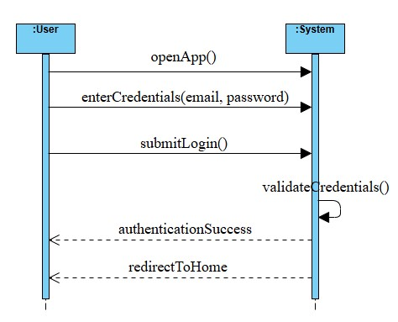
Figure 2.2 login/signup SSD 2.9.2 Set/Update Location

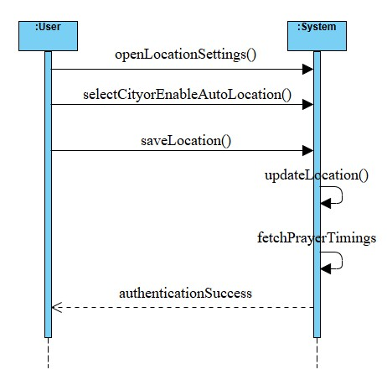
Figure 2.3 Set/Update location SSD

2.9.3 Mark/Unmark Prayer

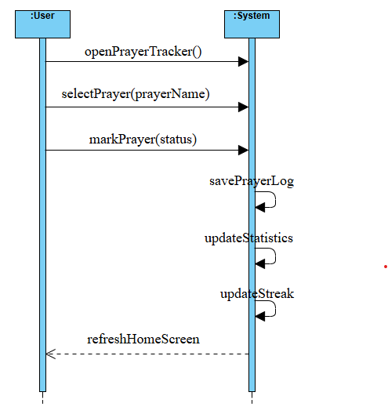
Figure 2.4 Mark/Unmark Prayers SSD

2.9.4 View Prayer Logs

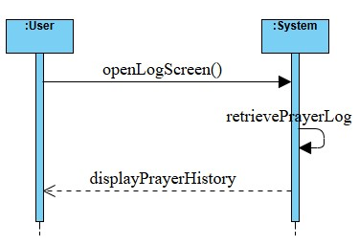
Figure 2.5 View Prayer logs SSD

2.9.5 View Prayer Statistics

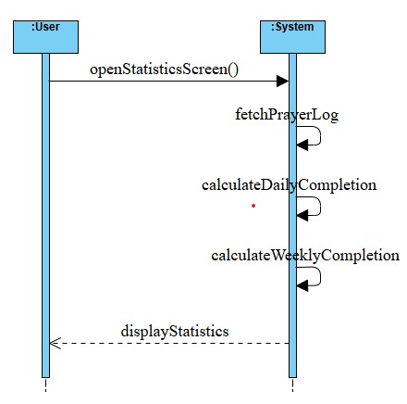
Figure 2.6 View Prayer Statistics SSD 2.9.6 Receive Motivational Messages

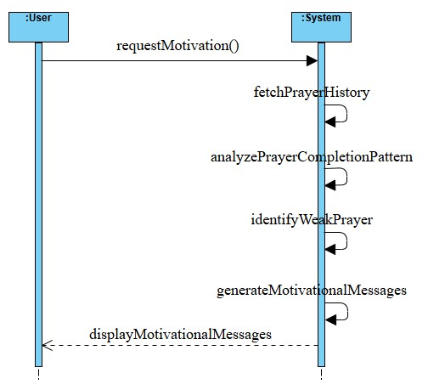
Figure 2.7 Receive Motivational Messages SSD

2.9.7 Manage Notifications

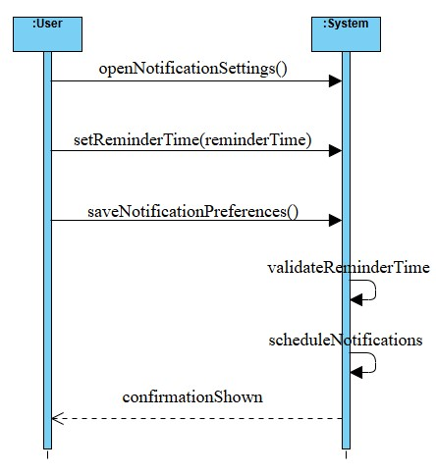
Figure 2.8 Manage Notifications SSD

2.9.8 Select Notification Tone

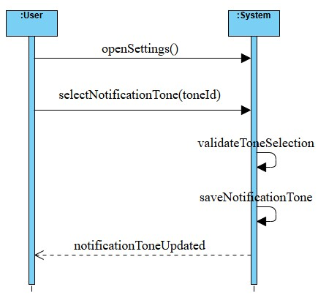
Figure 2.9 Select Notification Tone SSD

2.9.9 Manage Profile

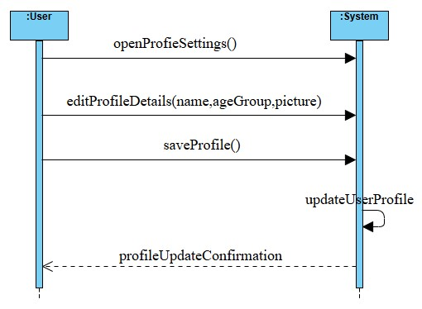
Figure 2.10 Manage Profile SSD 2.9.10 Change Theme

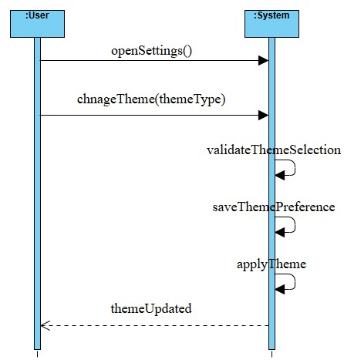
Figure 2.11 Change Theme SSD

2.9.11 View Hijri Calendar

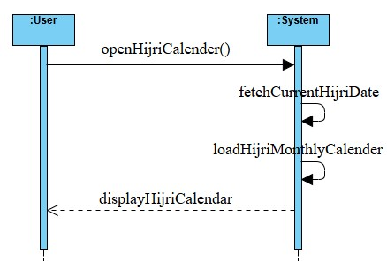
Figure 2.12 View Hijri Calendar SSD 2.9.12 Read Quran Pak

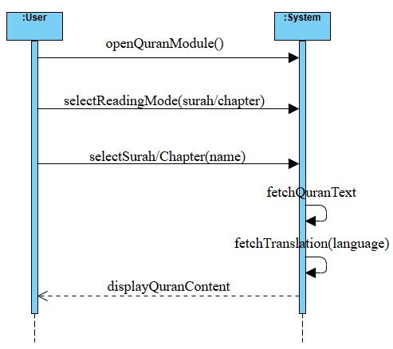
Figure 2.13 Read Quran Pak SSD

2.9.13 View Asma-ul-Husna

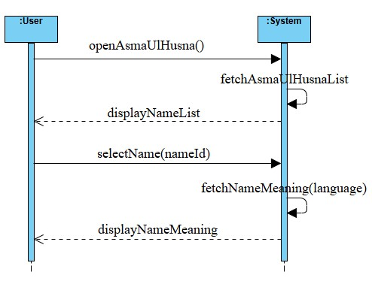

Figure 2.14 View Asma-ul-Husna SSD

2.10 Domain Model

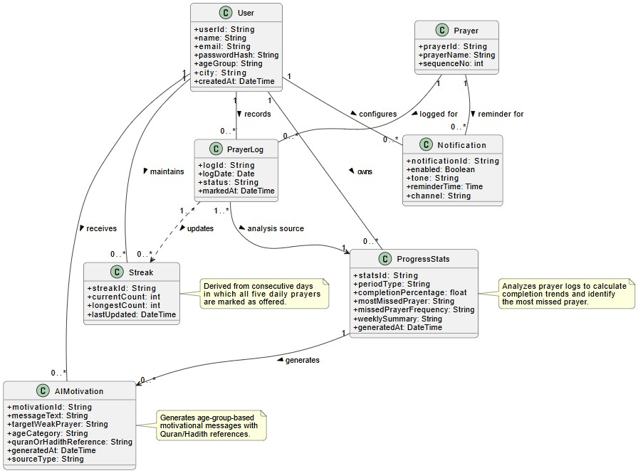

Figure 2.15 Domain Model

2.11 Class Diagram

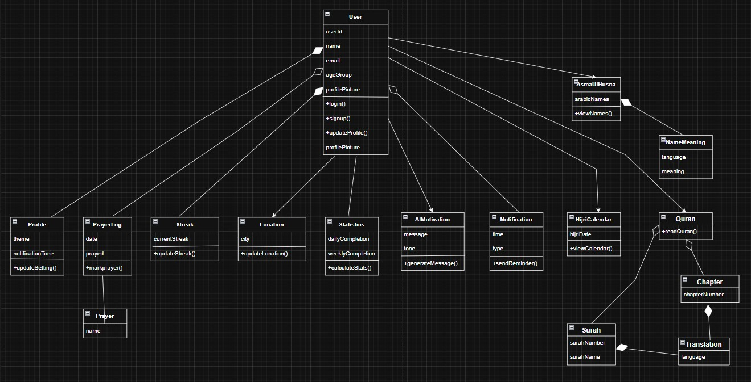

Figure 2.16 Class Diagram

2.12 Entity Relationship Diagram (ERD)
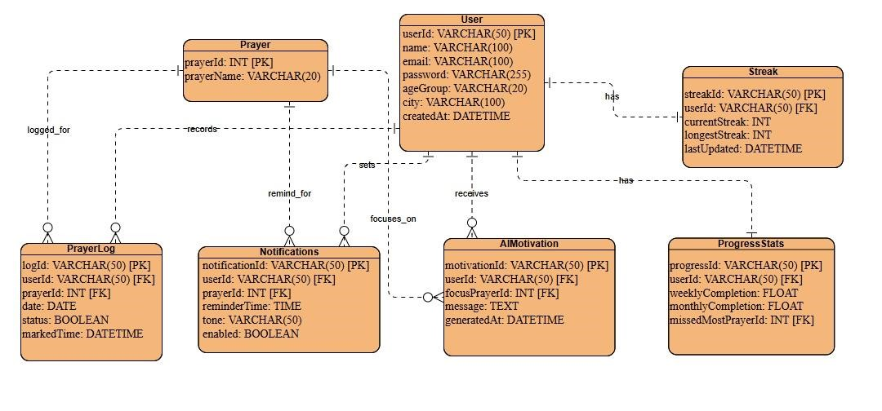

Figure 2.17 Entity Relationship Diagram

CHAPTER NUMBER 3

SYSTEM DESIGN

- System Design:
This third chapter introduces the design of the system. System design is the initial phase before implementing a system. It entails the definition of architecture, modules, interfaces and flow to address certain requirements. It graphically shows the interaction of various parts/ modules in order to give intended functionality.
  - Architecture Diagram
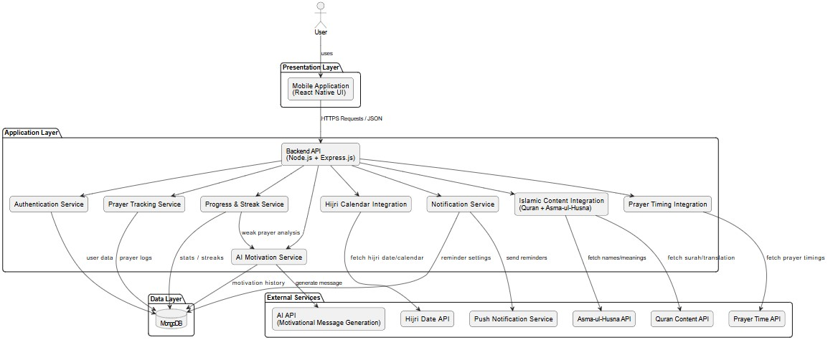
Figure 3.1 Architecture Diagram

  - Sequence Diagram
A sequence diagram is an interaction diagram that shows how objects operate with one another and what order. A sequence diagram shows object interactions and arranged them in time sequence. It depicts the objects and class involved in the scenario and the sequence of messages exchange between the objects needed to carry out the functionality of the scenario. Sequence diagrams are developed against the use cases.

3.2.1 Login/ Sign Up

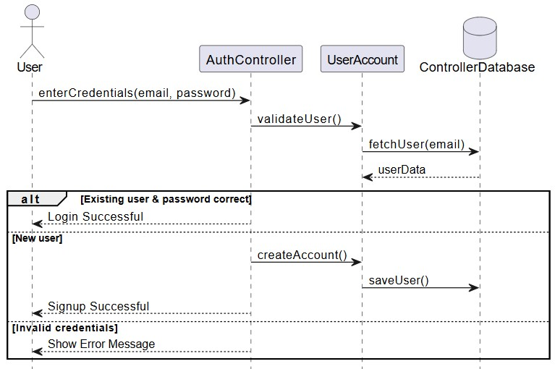
Figure 3.2 Login/signup SD

3.2.2 Set/ Update Location
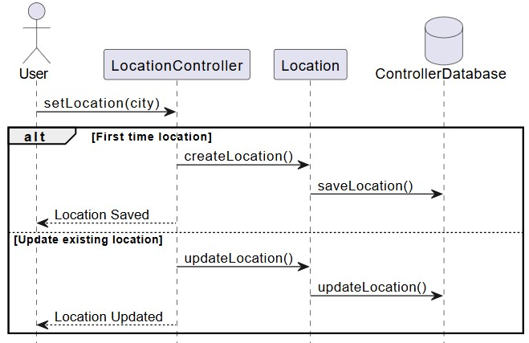
Figure 3.3 Set/Update location SD

3.2.3 Mark/Unmark Prayer
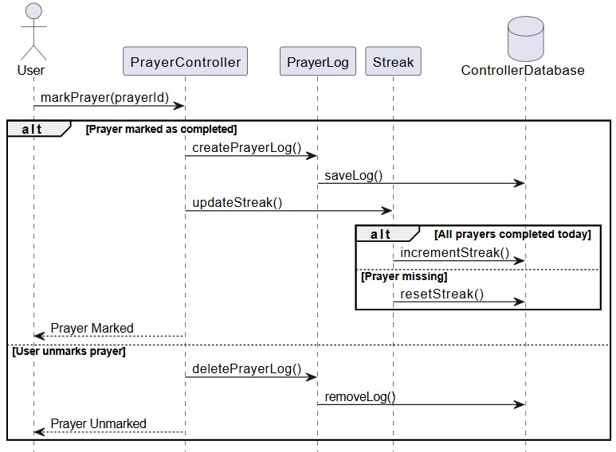
Figure 3.4 Mark/Unmark SD

3.2.4 View Prayer Logs

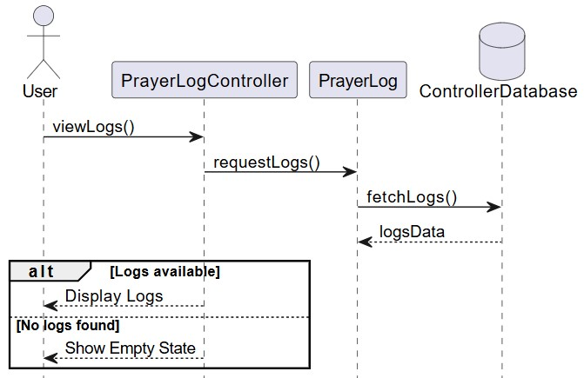
Figure 3.5 View Prayer logs SD

.5 View Prayer Stats
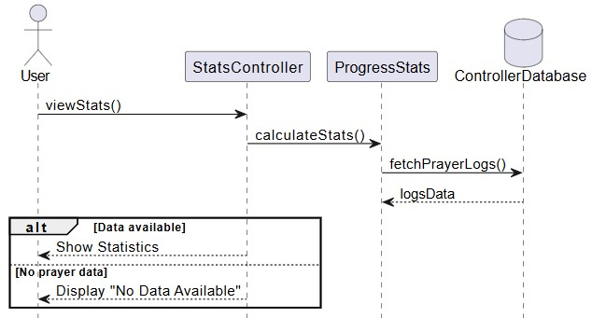
Figure 3.6 View Prayer Statistics SD

3.2.6 Receive Motivational Messages
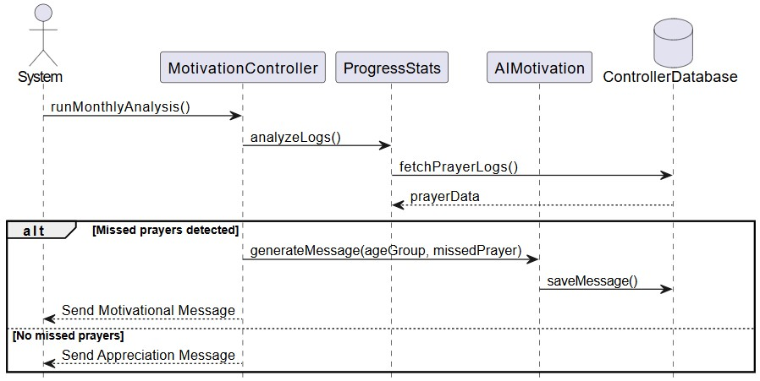
Figure 3.7 Receive Motivational Messages SD

.7 Manage Notifications
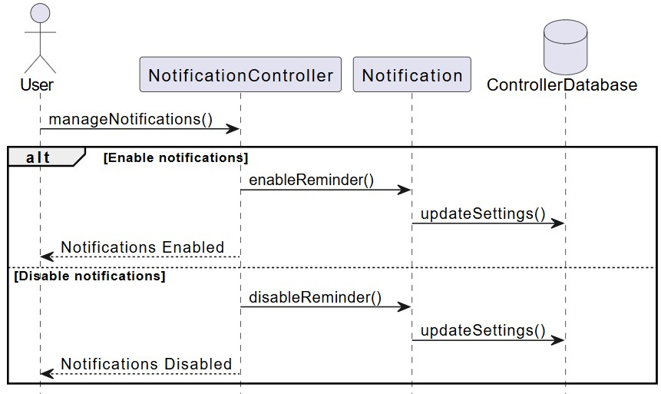
Figure 3.8 Manage Notifications SD

3.2.8 Select Notification Tone
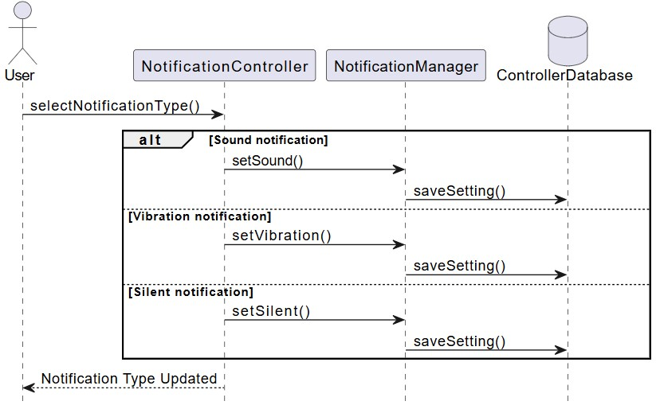
Figure 3.9 Select Notification Tone SD

.9 Manage Profile
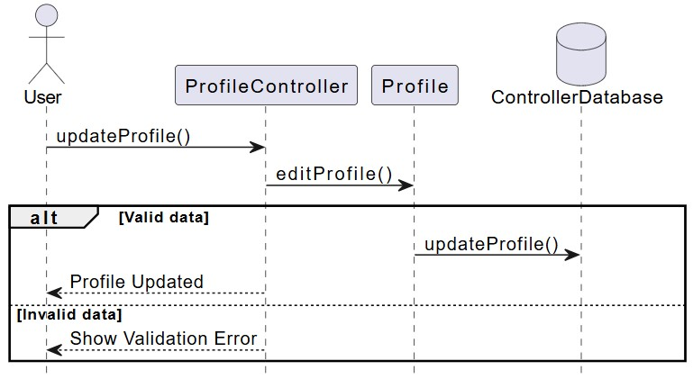
Figure 3.10 Manage Profile SD

3.2.10 Change Theme
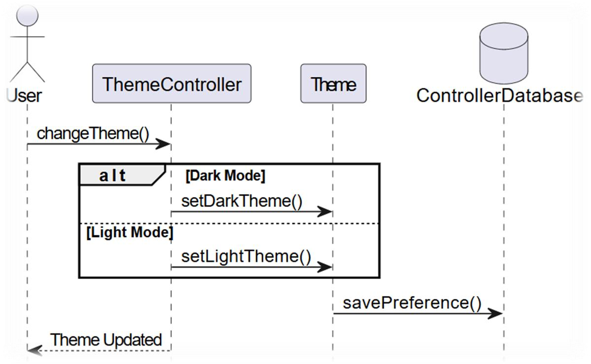
Figure 3.11 Change Theme SD

.11 View Hirji Calendar
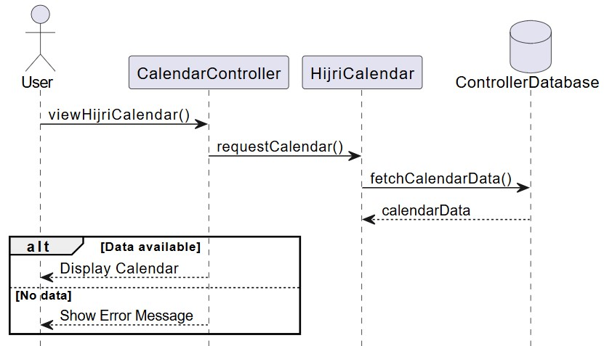
Figure 3.12 View Hijri Calendar SD

3.2.12 Read Quran Pak
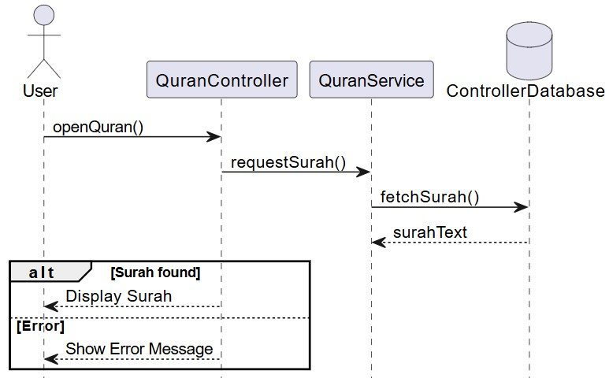
Figure 3.13 Read Quarn Pak SD

.13 View Asma-ul-Husna

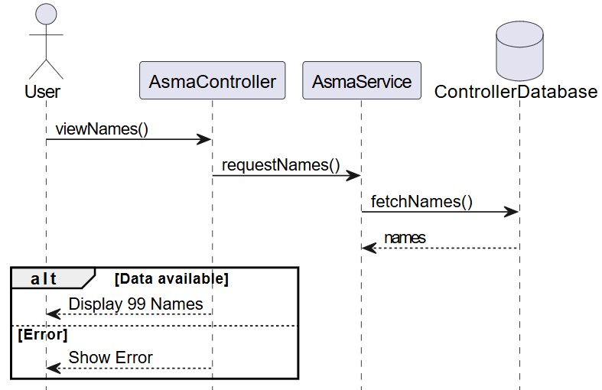

Figure 3.14 View Asma-ul-Husna SD

3.3 Interface Design
This section presents the UI/UX screens of the proposed system, designed according to the identified requirements and user interactions. These screens serve as visual prototypes and guide the implementation of the final application.

3.3.1 Login/Signup
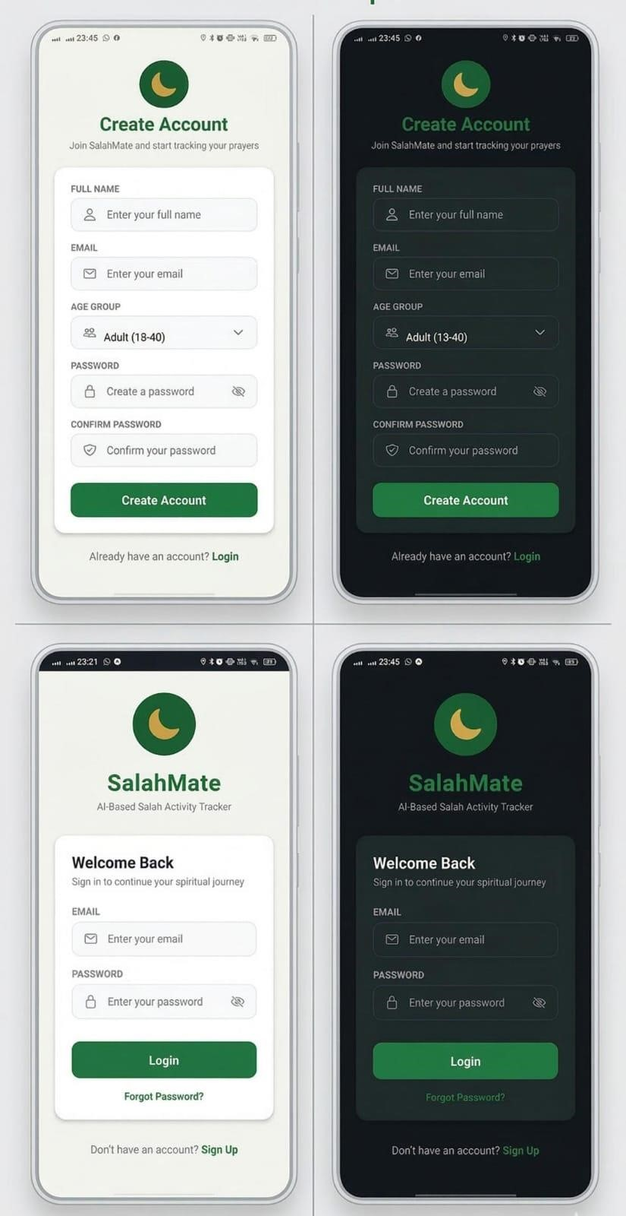
Figure 3.15 login/signup screen

3.3.2 Home Screen
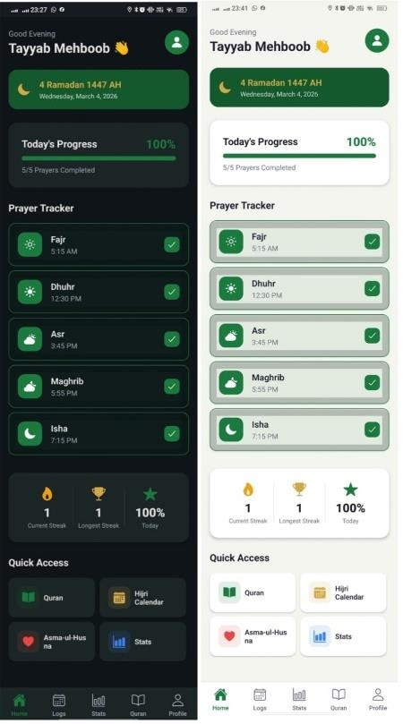
Figure 3.16 Home screen

3.3.3 Statistics
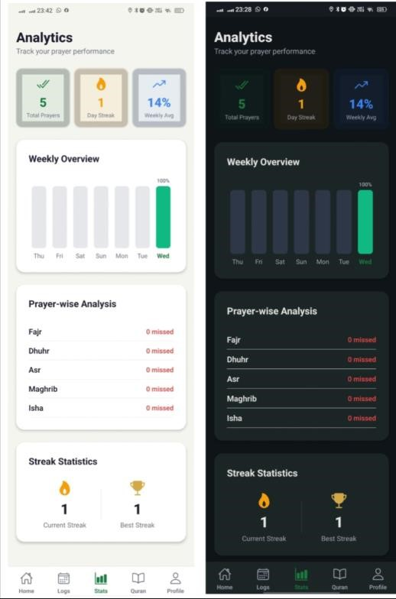
Figure 3.17 Statistics screen

3.3.4 Hijri Calendar
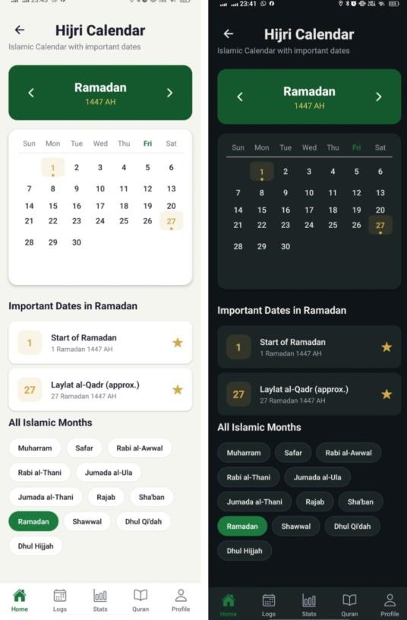
Figure 3.18 Hijri Calendar screen

3.3.5 Quran Pak Screen
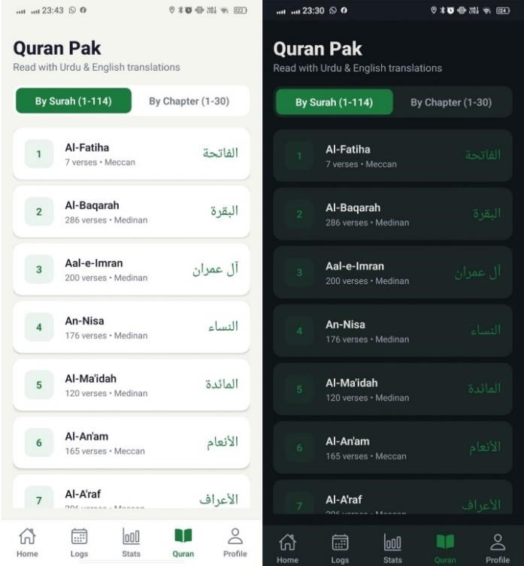
Figure 3.19 Quran Pak screen

3.3.6 Prayer logs Screen
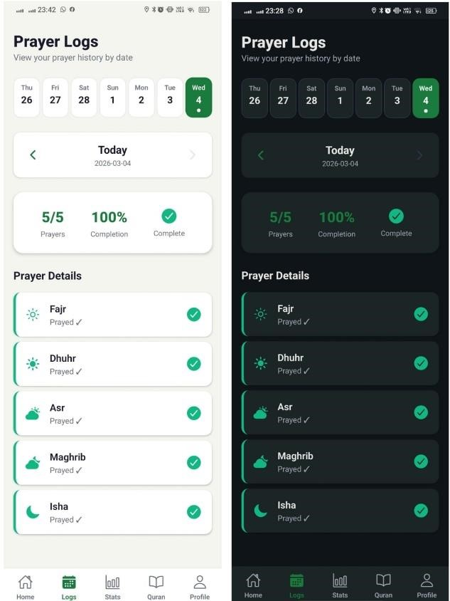
Figure 3.20 Prayer logs screen

3.3.7 Setting Screen
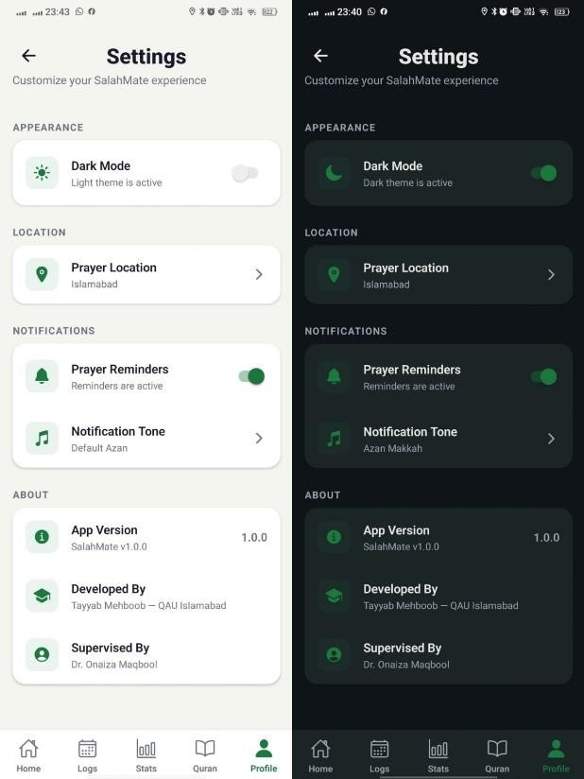
Figure 3.21 Setting screen

CHAPTER NUMBER 4

SOFTWARE TESTING

4.1 Introduction
The Salah Activity Tracker needs to be tested. This will be done by following a test document. This document says what tests will be done to check if the application works as, it should. The development of test cases also assists in identifying potential issues in the system requirements, design and implementation at an early stage.

4.2 Test plan
Test planning is a well-organized practice that makes sure that all testing activities and milestones are adequately perceived and recorded. The test plan identifies the scope of testing, features to be tested, potential risks and features that are out of scope. It also establishes the pass and fail criteria of each test case to establish whether the system works as one expects. The goal of the test plan is to ensure the correctness, reliability and usability of Salah Activity Tracker application.

4.3 Features for Testing
Features to be tested are following:
- User Login and Signup
- Prayer Tracking (Marking prayers as prayed/ not prayed)
- Prayers Logs and History
- Streak Calculation
- Location-based Prayer Timings
- Hijri Calendar (Current date and full calendar view)
- Quran Pak (Reading by Surah and Chapter with Urdu and English Translation)
- Asma-ul-Husna (Viewing names with meanings)
- AI-based Motivational Messages
- Prayer Reminder Notifications

4.4 Test Cases

4.4.1 User Login and Signup
ID | T1
Description | The user logs into the application or creates a new account.
Tester | User
Setup | User opens the mobile application
Instructions | - Opens the application  - Select Login/ Signup option  - Enter valid email and password
 | • Select Login or Signup
Expected Results | User is authenticated and redirected to home screen
Table 4.1 Test case for login/signup

4.4.2 Prayer Tracking (Mark prayed/ not Prayed)
ID | T2
Description | User makes a prayer as prayed or not prayed
Tester | User
Setup | User is logged into the application
Instruction | - Open home screen  - Select a prayer (Fajr, Dhuhr, Asr, Maghrib, Isha)  - Mark prayer as prayed or not prayed
Expected Results | Prayer status is saved successfully
Table 4.2 Test case for Prayer Tracking

4.4.3 Prayer Logs and history
ID | T3
Description | User views previous prayer records
Tester | User
Setup | User is logged into the application
Instruction | - Open prayer history selection  - Select a date
Expected Results | Prayer logs for selected date are displayed
Table 4.3 Test case for Prayer logs and History

4.4.4 Streak Calculation
ID | T4
Description | System calculates and displays prayer streak
Tester | User
Setup | User has prayer history
Instruction | • Open home screen
Expected Results | Current and longest streak are displayed correctly
Table 4.4 Test case for Streak Calculation

4.4.5 Location-based prayer timings
ID | T5
Description | System displays prayer timings based on your location
Tester | User
Setup | User has enabled location access
Instruction | • Open home screen
Expected Results | Correct prayer timings for selected city are displayed
Table 4.5 Test case for location-based prayer timings

4.4.6 Hijri Calendar
ID | T6
Description | User views current Hijri date and full Hijri  Calendar
Tester | User
Setup | User is logged in
Instruction | • Open Hijri calendar section
Expected Results | Current Hijri date and calendar are displayed
Table 4.6 Test case for Hijri Calendar

4.4.7 Quran Pak (Surah and Chapter with Translation)
ID | T7
Description | User reads Quran Pak by Surah or Chapter with  Translation
Tester | User
Setup | User is logged in
Instruction | - Open Quran section  - Select Surah or Chapter  - Select Urdu or English translation
Expected Results | Selected Quran text with translation is displayed
Table 4.7 Test case for Quran Pak

4.4.8 Asma-ul-Husna
ID | T8
Description | User views Asma-ul-Husna with meanings
Tester | User
Setup | User is logged in
Instruction | Open Asma-ul-Husna section
Expected Results | Names with meanings are displayed
Table 4.8 Test case for Asma-ul-Husna

4.4.9 AI-based Motivational Messages
ID | T9
Description | System generates motivational messages based on prayer activity
Tester | User
Setup | User has prayer history
Instruction | Open Home screen
Expected Results | Motivational message is displayed
Table 4.9 Test case for AI-based Motivational Messages

4.4.10 Prayer Remainder Notification
ID | T10
Description | System sends prayer reminder notifications
Tester | User
Setup | User has enabled notifications
Instruction | Wait for prayer time
Expected Results | Notification received at correct prayer time
Table 4.10 Test case for Prayer Remainder Notification

